1)ArithmeticException
public class ArithmeticExceptionDemo {
public static void main(String[] args) {
try {
int a = 10;
int b = 0;
int c = a / b;
System.out.println(c);
} catch (ArithmeticException e) {
System.out.println("Cannot divide by zero.");
}
}
}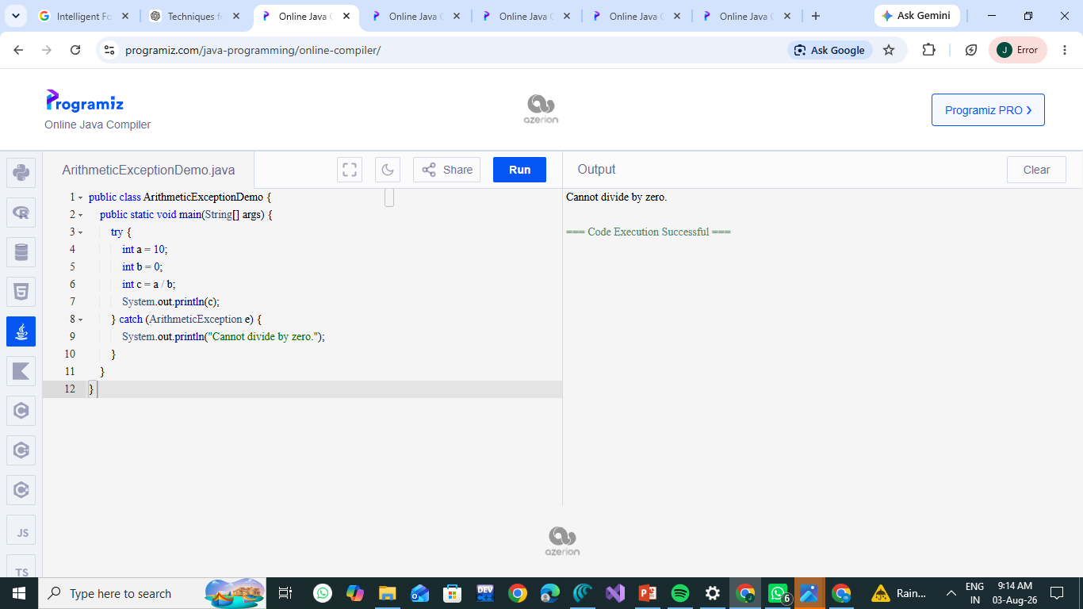

2)Null Pointer Exception
public class NullPointerExceptionDemo {
public static void main(String[] args) {
try {
String str = null;
System.out.println(str.length());
} catch (NullPointerException e) {
System.out.println("Object reference is null.");
}
}
}
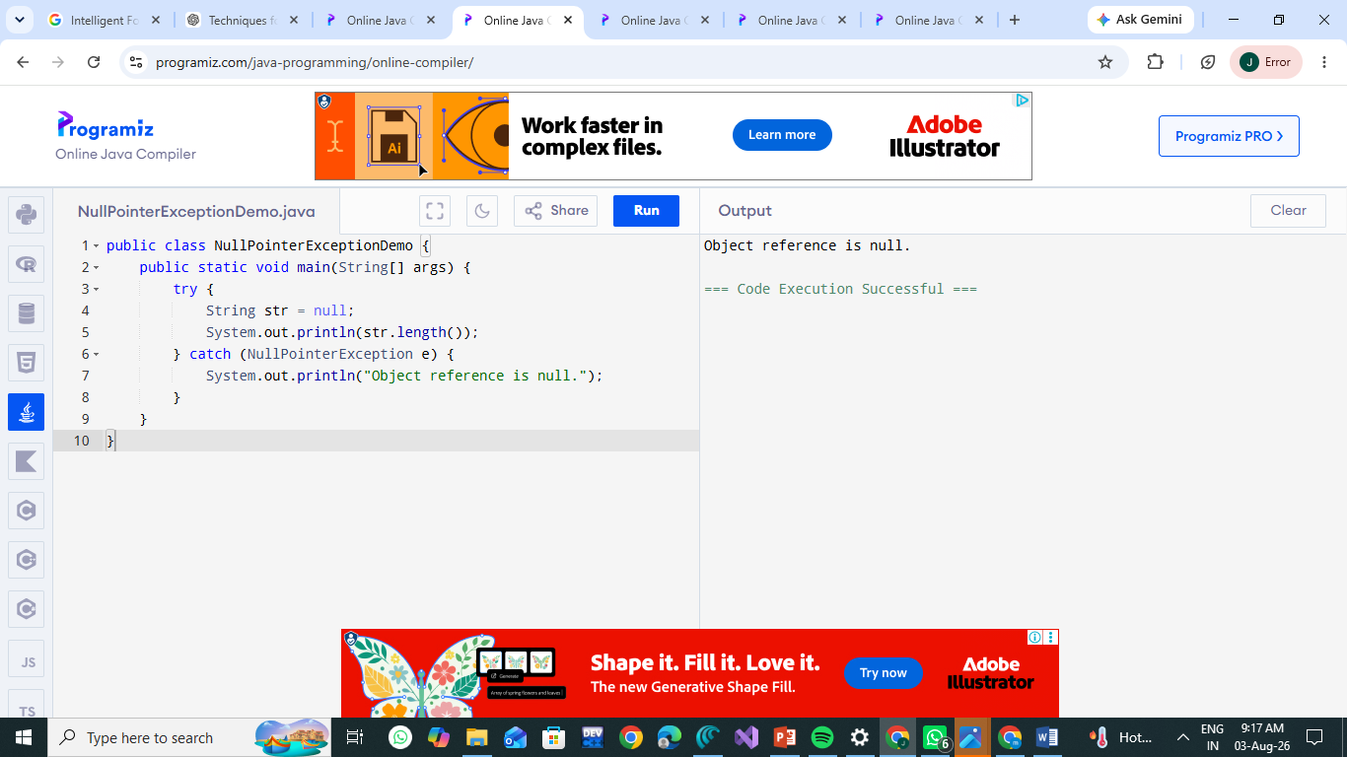

3)Number Format Exception
public class NumberFormatExceptionDemo {
public static void main(String[] args) {
try {
String str = "ABC";
int num = Integer.parseInt(str);
System.out.println(num);
} catch (NumberFormatException e) {
System.out.println("Invalid number. Cannot convert String to Integer.");
}
}
}
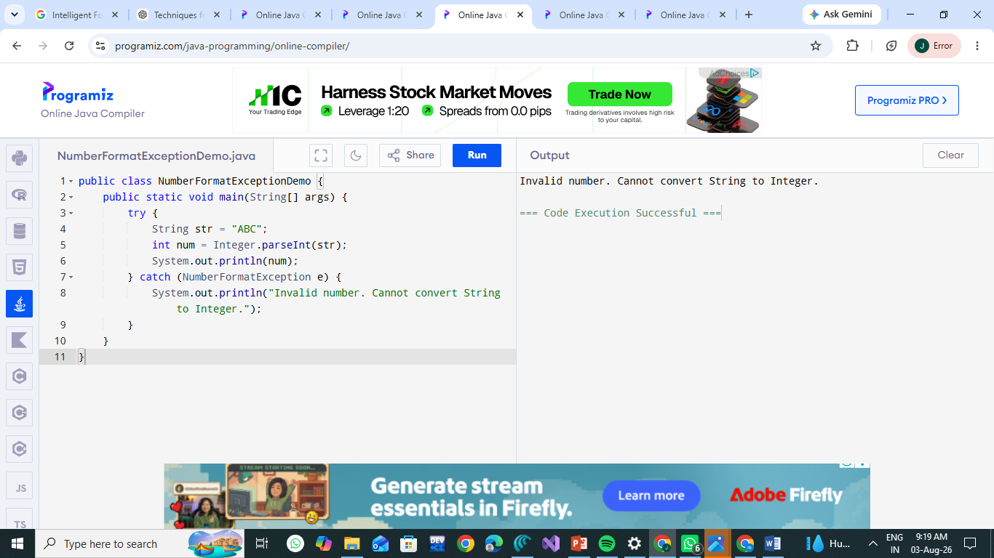

4)Array Index Out Of Bounds Exception
public class ArrayIndexOutOfBoundsDemo {
public static void main(String[] args) {
try {
int[] arr = {10, 20, 30};
System.out.println(arr[5]);
} catch (ArrayIndexOutOfBoundsException e) {
System.out.println("Invalid array index.");
}
}
}
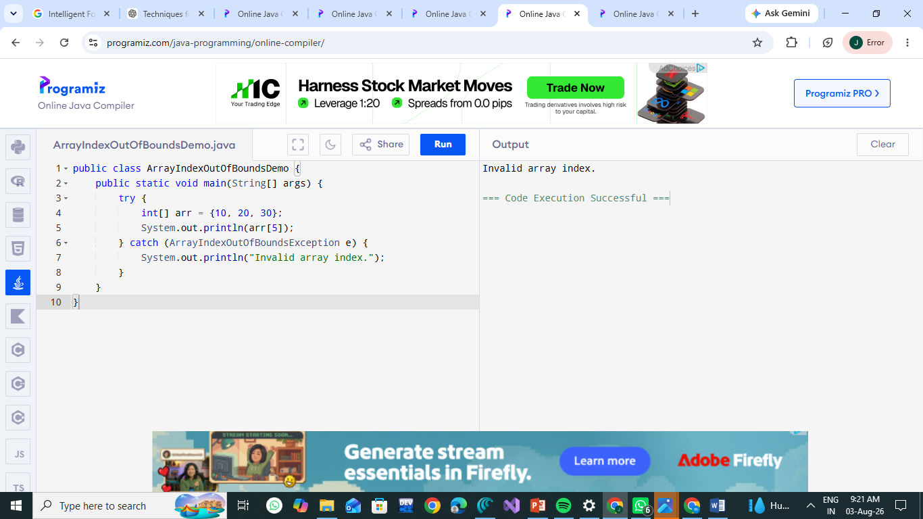
5) Try-Catch
public class TryCatchDemo {
public static void main(String[] args) {
try {
int a = 10;
int b = 0;
int c = a / b;
System.out.println(c);
} catch (ArithmeticException e) {
System.out.println("Cannot divide by zero.");
}

System.out.println("Program continues...");
}
}
